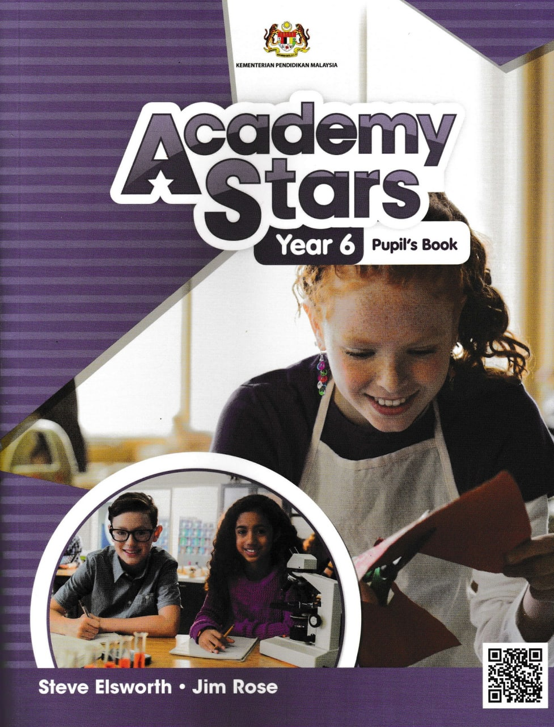  RANCANGAN PENGAJARAN TAHUNAN BAHASA INGGERIS TAHUN 6 (SK)  2024/2025 | SCHOOL NAME:  ___________________________________  SCHOOL ADDRESS:  ___________________________________  TEACHER’S NAME:  ___________________________________  CLASS:  ___________________________________

UNIT/WEEK/  TOPIC | LISTENING | SPEAKING | READING | WRITING | LANGUAGE ARTS
WEEK 1 | ORIENTATION WEEK
Welcome Unit  WELCOME  UNIT 1  It’s an emergency!  WEEK 2  WEEK 3  (LP Civic Edu Mac)  WEEK 4  WEEK 6  (LP 1-16) | 1.1.1  Recognise and reproduce  independently a wide range of target language  phonemes  1.2.1  Understand with little or no support the main idea of longer simple texts on a range of familiar topics  1.2.2  Understand with little or no support specific  information and details of longer simple texts on a  range of familiar topics  1.2.5  Understand more complex  supported questions | 2.1.1  Give detailed  information about  themselves and others  2.1.3  Explain and give reasons for simple advice  2.1.5  Ask about and describe  personality.  2.3.1  Narrate short stories, events and experiences | 3.2.1  Understand the  main idea of simple longer texts  3.2.2  Understand specific  information and  details of simple  longer texts  3.2.3  Guess the meaning of  unfamiliar words from clues provided by other  known words and  by context | 4.2.1  Give detailed information about themselves and others  4.2.3  Narrate factual and imagined events and  experiences  4.2.4  Describe personality  4.3.1 Use capital letters, full stops, commas in lists, question marks, and speech marks appropriately at discourse level  4.3.2  Spell most high frequency words accurately in  independent writing  4.3.3  Produce a plan or draft of two  paragraphs or more for a familiar topic and modify  this appropriately in response to feedback | 5.3.1  Respond  imaginatively and  intelligibly through  creating simple  stories and simple  poems  Other imaginative  responses as  appropriate
WEEK 5 | CUTI PERAYAAN - HARI RAYA AIDILFITRI

UNIT/WEEK/  TOPIC | LISTENING | SPEAKING | READING | WRITING | LANGUAGE ARTS
Unit 2  LIFE IN THE PAST  WEEK 6  WEEK 7  (LP Civic Edu Apr)  WEEK 8  WEEK 9  (LP 17-32) | 1.1.1  Recognise and reproduce with little or no support a wide range of target language phonemes  1.2.1  Understand with support the main idea of longer simple texts on a range of familiar topics  1.2.2  Understand with support specific information and details of longer simple texts on a range of familiar topics  1.2.5  Understand a sequence of supported questions | 2.1.1  Give detailed information about  themselves and  others  2.1.4  Ask about and describe future plans or events  2.2.1  Keep interaction going in short exchanges by asking suitable questions  2.2.2  Agree a set of basic steps needed to complete extended  classroom tasks | 3.2.1  Understand the main idea of simple  texts of two paragraphs or more  3.2.2  Understand specific information and  details of two paragraphs or more  3.2.3  Guess the meaning of  unfamiliar words from clues provided by other  known words and by context  3.2.4  Use with support familiar print and digital resources to check meaning | 4.2.1  Give detailed information about themselves  4.2.3  Narrate factual and imagined events and  experiences  4.3.1  Use capital letters, full stops, commas in lists,  question marks, and speech marks appropriately at discourse level  4.3.2  Spell a range of high frequency words accurately in independent writing  4.3.3  Produce a plan or draft of two paragraphs or more for a familiar topic and modify this appropriately  in response to feedback | 5.3.1  Respond imaginatively and intelligibly through creating simple role-plays and simple poems  Other imaginative responses as appropriate

UNIT/WEEK/  TOPIC | LISTENING | SPEAKING | READING | WRITING | LANGUAGE ARTS
Unit 3  ADVENTURE TIME  WEEK 10  WEEK 11  *CUTI PENGGAL 1  WEEK 12  WEEK 13  (LP 33-48) | 1.2.2  Understand with support specific information and details of longer simple texts on a range of familiar topics  1.2.3  Understand with little or no support longer simple narratives on a range of familiar topics  1.2.5  Understand a sequence of supported questions  1.3.1  Guess the meaning of unfamiliar words from clues provided by other known words and by context on familiar topics | 2.1.1  Give detailed information about  themselves and  others  2.3.1  Narrate short stories, events and experiences | 3.2.1  Understand the main idea of simple  texts of two paragraphs or more  3.2.2  Understand specific information and  details of two paragraphs or more  3.3.1  Read and enjoy A2 fiction/non-fiction  print and digital texts of interest | 4.2.1  Give detailed information about themselves  4.2.3  Narrate factual and imagined events and  experiences  4.2.5  Connect sentences into one or two coherent paragraphs using basic coordinating conjunctions and reference pronouns  4.3.1  Use capital letters, full stops, commas in lists,  question marks, and speech marks appropriately at discourse level  4.3.3  Produce a plan or draft of two paragraphs or more for a familiar topic and modify this appropriately  in response to feedback | 5.2.1  Explain in simple language why they like or dislike an event, description or character in a text  5.3.1  Respond imaginatively and intelligibly through creating simple role-plays and simple poems  Other imaginative responses as appropriate
CUTI PENGGAL 1, SESI 2024/2025
KUMPULAN A: 24.05.2024 - 02.06.2024, KUMPULAN B: 25.05.2024 - 02.06.2024

UNIT/WEEK/  TOPIC | LISTENING | SPEAKING | READING | WRITING | LANGUAGE ARTS
Unit 4  COOL JOBS  WEEK 14  WEEK 15  WEEK 16  WEEK 17  (LP 49-64) | 1.2.1  Understand with support the main idea of longer simple texts on a range of familiar topics  1.2.2  Understand with support specific information and details of longer simple texts on a range of familiar topics  1.2.5  Understand a sequence of supported questions  1.3.1  Guess the meaning of unfamiliar words from clues provided by other known words and by context on familiar topics | 2.1.1  Give detailed information about  themselves and  others  2.2.1  Keep interaction going in short exchanges by asking suitable questions | 3.2.2  Understand specific information and  details of two paragraphs or more  3.2.3  Guess the meaning of  unfamiliar words from clues provided by other  known words and by context  3.2.4  Use with support familiar print and digital resources to check meaning | 4.2.1  Give detailed information about themselves  4.2.2  Describe future plans or events  4.2.4  Describe people, places and objects using suitable statements  4.3.1  Use capital letters, full stops, commas in lists,  question marks, and speech marks appropriately at discourse level  4.3.2  Spell a range of high frequency words accurately in independent writing | 5.2.1  Explain in simple language why they like or dislike an event, description or character in a text

UNIT/WEEK/  TOPIC | LISTENING | SPEAKING | READING | WRITING | LANGUAGE ARTS
Unit 5  GETTING AROUND  WEEK 17  WEEK 18  WEEK 19  WEEK 20  (LP 65-80) | 1.1.1  Recognise and reproduce with little or no support a wide range of target language phonemes  1.2.2  Understand with support specific information and details of longer simple texts on a range of familiar topics  1.2.3  Understand with little or no support longer simple narratives on a range of familiar topics  1.2.5  Understand a sequence of supported questions  1.3.1  Guess the meaning of unfamiliar words from clues provided by other known words and by context on familiar topics | 2.1.1  Give detailed information about themselves and  others  2.1.2  Find out about and describe experiences up to now  2.1.3  Explain and give reasons for simple advice  2.2.1  Keep interaction going in short exchanges by asking suitable questions  2.2.2  Agree a set of basic steps needed to complete extended classroom tasks  2.3.1  Narrate short stories, events and experiences | 3.2.1  Understand the main idea of simple texts of two paragraphs or more  3.2.2  Understand specific information and  details of two paragraphs or more  3.3.1  Read and enjoy A2 fiction/non-fiction  print and digital texts of interest | 4.2.1  Give detailed information about themselves  4.2.3  Narrate factual and imagined events and  experiences  4.2.5  Connect sentences into one or two coherent paragraphs using basic coordinating conjunctions and reference pronouns  4.3.3  Produce a plan or draft of two paragraphs or more for a familiar topic and modify this appropriately  in response to feedback | 5.3.1  Respond imaginatively and intelligibly through creating simple role-plays and simple poems  Other imaginative responses as appropriate

UNIT/WEEK/  TOPIC | LISTENING | SPEAKING | READING | WRITING | LANGUAGE ARTS
Unit 6  HOW IS IT MADE?  WEEK 21  WEEK 22  WEEK 23  (LP 81-96) | 1.1.1  Recognise and reproduce with little or no support a wide range of target language phonemes  1.2.1  Understand with support the main idea of longer simple texts on a range of familiar topics  1.2.2  Understand with support specific information and details of longer simple texts on a range of familiar topics  1.2.4  Understand longer sequences  of supported classroom  instructions  1.2.5  Understand a sequence of supported questions | 2.1.1  Give detailed information about  themselves and  others  2.1.3  Explain and give  reasons for simple  advice  2.2.2  Agree a set of basic steps needed to complete extended  classroom tasks | 3.2.1  Understand the main idea of simple texts of two paragraphs or more  3.2.2  Understand specific information and  details of two paragraphs or more  3.2.4  Use with support familiar print and digital resources to check meaning | 4.2.5  Connect sentences into one or two coherent paragraphs using basic coordinating conjunctions and reference pronouns  4.3.1  Use capital letters, full stops, commas in lists,  question marks, and speech marks appropriately at discourse level  4.3.2  Spell a range of high frequency words accurately in independent writing  4.3.3  Produce a plan or draft of two paragraphs or more for a familiar topic and modify this appropriately  in response to feedback | 5.2.1  Explain in simple language why they like or dislike an event, description or character in a text  5.3.1  Respond imaginatively and intelligibly through creating simple role-plays and simple poems  Other imaginative responses as appropriate
CUTI PENGGAL 2, SESI 2024/2025
KUMPULAN A: 13.09.2024 - 21.09.2024, KUMPULAN B: 14.09.2024 - 22.09.2024

UNIT/WEEK/  TOPIC | LISTENING | SPEAKING | READING | WRITING | LANGUAGE ARTS
Unit 7  MUSIC AND SONG  WEEK 24  WEEK 25  WEEK 26  WEEK 27  (LP 97-112) | 1.1.1  Recognise and reproduce with little or no support a wide range of target language phonemes  1.2.1  Understand with support the main idea of longer simple texts on a range of familiar topics  1.2.2  Understand with support specific information and details of longer simple texts on a range of familiar topics  1.2.3  Understand with little or no support longer simple narratives on a range of familiar topics  1.3.1  Guess the meaning of unfamiliar words from clues provided by other known words and by context on familiar topics | 2.1.1  Give detailed information about  themselves and  others  2.1.4  Ask about and describe future plans or events  2.1.5  Describe people, places and objects using suitable statements  2.2.1  Keep interaction going in short exchanges by asking suitable questions  2.3.1  Narrate short stories, events and experiences | 3.2.1  Understand the main idea of simple texts of two paragraphs or more  3.2.2  Understand specific information and  details of two paragraphs or more  3.3.1  Read and enjoy A2 fiction/non-fiction  print and digital texts of interest | 4.2.1  Give detailed information about themselves  4.2.2  Describe future plans or events  4.2.5  Connect sentences into one or two coherent paragraphs using basic coordinating conjunctions and reference pronouns  4.3.1  Use capital letters, full stops, commas in lists,  question marks, and speech marks appropriately at discourse level  4.3.2  Spell a range of high frequency words accurately in independent writing | 5.3.1  Respond imaginatively and intelligibly through creating simple role-plays and simple poems  Other imaginative responses as appropriate

UNIT/WEEK/  TOPIC | LISTENING | SPEAKING | READING | WRITING | LANGUAGE ARTS
Unit 8  TELL ME A STORY  WEEK 28  WEEK 29  WEEK 30  (LP 113-128) | 1.2.1  Understand with support the main idea of longer simple texts on a range of familiar topics  1.2.2  Understand with support specific information and details of longer simple texts on a range of familiar topics  1.2.3  Understand with little or no support longer simple narratives on a range of familiar topics  1.2.5  Understand a sequence of supported questions | 2.1.3  Explain and give  reasons for simple  advice  2.1.4  Ask about and describe future plans or events  2.3.1  Narrate short stories, events and experiences | 3.2.1  Understand the main idea of simple texts of two paragraphs or more  3.2.2  Understand specific information and  details of two paragraphs or more  3.3.1  Read and enjoy A2 fiction/non-fiction  print and digital texts of interest | 4.2.2  Describe future plans or events  4.2.3  Narrate factual and imagined events and experiences  4.2.5  Connect sentences into one or two coherent paragraphs using basic coordinating conjunctions and reference pronouns  4.3.1  Use capital letters, full stops, commas in lists, question marks, and speech marks appropriately at discourse level  4.3.3  Produce a plan or draft of two paragraphs or more for a familiar topic and modify this appropriately in response to feedback | 5.2.1  Explain in simple language why they like or dislike an event, description or character in a text  5.3.1  Respond imaginatively and intelligibly through creating simple role-plays and simple poems  Other imaginative responses as appropriate

UNIT/WEEK/  TOPIC | LISTENING | SPEAKING | READING | WRITING | LANGUAGE ARTS
Unit 9  WHAT’S YOUR OPINION?  WEEK 31  WEEK 32  WEEK 33  WEEK 34  (LP 129-144) | 1.2.1  Understand with support the main idea of longer simple texts on a range of familiar topics  1.2.2  Understand with support specific information and details of longer simple texts on a range of familiar topics  1.2.3  Understand with little or no support longer simple narratives on a range of familiar topics  1.2.5  Understand a sequence of supported questions | 2.1.1  Give detailed information about  themselves and  others  2.1.4  Ask about and describe future plans or events  2.2.1  Keep interaction going in short exchanges by asking suitable questions  2.2.2  Agree a set of basic steps needed to complete extended  classroom tasks | 3.2.1  Understand the main idea of simple texts of two paragraphs or more  3.2.2  Understand specific information and  details of two paragraphs or more  3.2.3  Guess the meaning of  unfamiliar words from clues provided by other  known words and by context  3.3.1  Read and enjoy A2 fiction/non-fiction  print and digital texts of interest | 4.2.1  Give detailed information about themselves  4.2.5  Connect sentences into one or two coherent paragraphs using basic coordinating conjunctions and reference pronouns  4.3.3  Produce a plan or draft of two paragraphs or more for a familiar topic and modify this appropriately  in response to feedback | 5.2.1  Explain in simple language why they like or dislike an event, description or character in a text  5.3.1  Respond imaginatively and intelligibly through creating simple role-plays and simple poems  Other imaginative responses as appropriate

UNIT/WEEK/  TOPIC | LISTENING | SPEAKING | READING | WRITING | LANGUAGE ARTS
Unit 10  IT’S A MYSTERY!  WEEK 35  WEEK 36  WEEK 37  WEEK 38  WEEK 39  (Revision)  (LP 145-160) | 1.2.2  Understand with support specific information and details of longer simple texts on a range of familiar topics  1.2.5  Understand a sequence of supported questions  1.3.1  Guess the meaning of unfamiliar words from clues provided by other known words and by context on familiar topics | 2.1.1  Give detailed information about  themselves and  others  2.1.2  Find out about and describe experiences up to now  2.1.5  Describe people, places and objects using suitable statements  2.2.1  Keep interaction going in short exchanges by asking suitable questions  2.3.1  Narrate short stories, events and experiences | 3.2.2  Understand specific information and  details of two paragraphs or more  3.3.1  Read and enjoy A2 fiction/non-fiction  print and digital texts of interest | 4.2.3  Narrate factual and imagined events and  experiences  4.3.1  Use capital letters, full stops, commas in lists,  question marks, and speech marks appropriately at discourse level  4.3.2  Spell a range of high frequency words accurately in independent writing | 5.2.1  Explain in simple language why they like or dislike an event, description or character in a text  5.3.1  Respond imaginatively and intelligibly through creating simple role-plays and simple poems  Other imaginative responses as appropriate
CUTI PENGGAL 3, SESI 2024/2025
KUMPULAN A: 20.12.2024 -28.12.2024, KUMPULAN B: 21.12.2024 -29.12.2024
WEEK 40 | PENTAKSIRAN AKHIR TAHUN
WEEK 41-42 | PENGURUSAN AKHIR TAHUN
CUTI AKHIR PERSEKOLAHAN SESI 2024/2025
KUMPULAN A: 17.01.2025 - 15.02.2025, KUMPULAN B: 18.01.2025 - 16.02.2025

CONTENT STANDARD FOR YEAR SIX

LISTENING | SPEAKING | READING | WRITING | LANGUAGE ART
1.1  Recognise and reproduce target language sounds | 2.1  Communicate simple information intelligibly | 3.2  Understand a variety of linear and non-linear print and digital texts by using appropriate reading strategies | 4.2  Communicate basic information intelligibly for a range of purposes in print and digital media | 5.2  Express personal responses to literary texts
1.2  Understand meaning in a variety of familiar contexts | 2.2  Use appropriate communication strategies | 3.3  Read independently for information and enjoyment | 4.3  Communicate with appropriate language form and style for a range of purposes in print and digital media | 5.3  Express an imaginative response to literary texts
1.3  Use appropriate listening strategies in a variety of contexts | 2.3  Communicate appropriately to a small or large group
#MEMERLUKAN RPH LENGKAP UNTUK SETAHUN DAN BORANG TRANSIT PBD?
#RPH2024/2025 coming soon on FEB 2024.

Sila order melalui website (Autosent by EMAIL): https://rphsekolahrendah.com
@ PM: 017- 4991 336 (WhatsApp link: https://wa.me/60174991336 )

Rozayus Whatsapp Channel (INFO DISKAUN): https://whatsapp.com/channel/0029VaBMmMlICVfgCkJq7x3n
TELEGRAM (FREE RPT & DSKP): https://telegram.me/RPTDSKPSekolahRendah
FB Group (FREE RPT): https://www.facebook.com/groups/freerpt/
FB Page (Contoh RPH): https://www.facebook.com/RozaYusAcademy/
Instagram: https://www.instagram.com/rozayus.academy/
Tiktok: https://www.tiktok.com/@rphrozayus

*UP: Diizinkan untuk share tanpa membuang maklumat yang disampaikan oleh Rozayus Academy

