

C:\Users\Win8\AppData\Local\Microsoft\Windows\Temporary Internet Files\Content.IE5\15ZKK3SE\MC910217711[1].wmf



**MAKLUMAT PERIBADI**

Nama : …………………………………

JPK(P) : …………………………………

No. KP: …………………………………

No Cukai: …………………………………

No Gaji: …………………………………

Jawatan: …………………………………

Tarikh Lahir: …………………………………

Tempat Lahir:…………………………………

Taraf Perkahwinan: Berkahwin/Bujang

Nama Suami/Isteri: ………………………………No.KP:…………………….

Pekerjaan Suami/Isteri: ……………………

Alamat Majikan Suami/Isteri…………………………………………………. …………………………………………………. No Tel:...............................

**Tarikh-Tarikh Penting**:

Tamat Ikhtisas:………………………….IPT:…………………………..

Tarikh Sah Jawatan:………………….. GRED:……………………….

Tarikh Lantikan Pertama: ………………………...

Tarikh Sah Pertama:………………………………

Tarikh Kenaikan Pangkat I:………………………. Gred:…………….

Tarikh Kenaikan Pangkat II:……………………… Gred:…………….

Tarikh Kenaikan Pangkat III:…………………….. Gred:…………….

Tarikh Masuk Skim Pencen:…………………….

Tarikh Isytihar Harta:……………………………..

**Sejarah Perkhidmatan**

|  |  |  |
| --- | --- | --- |
| BIL | NAMA SEKOLAH | TAHUN |
|  |  |  |
|  |  |  |
|  |  |  |
|  |  |  |
|  |  |  |

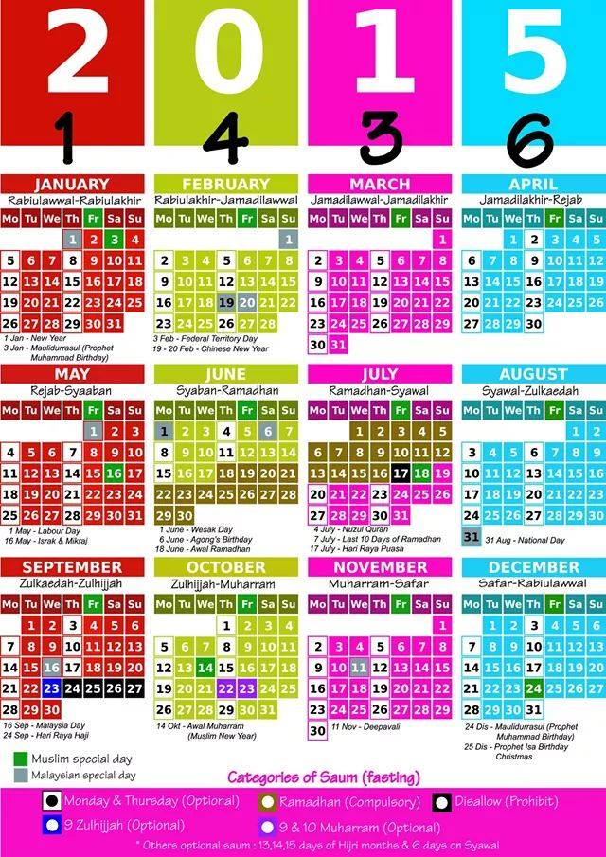

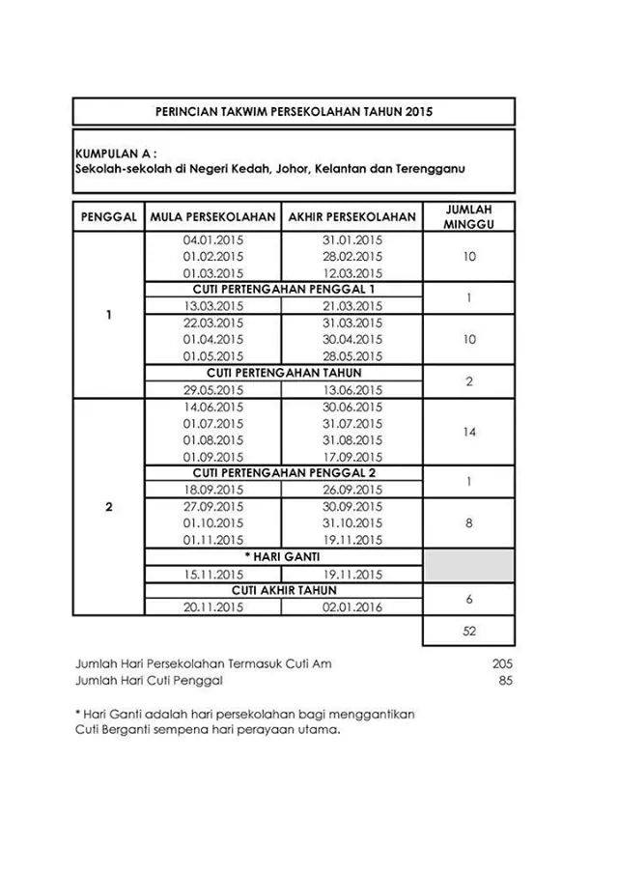

|  |  |
| --- | --- |
| BIDANG | JAWATAN |
| KURIKULUM |  |
|  |
|  |
|  |
|  |
|  |
|  |
| HAL EHWAL MURID |  |
|  |
|  |
|  |
|  |
|  |
| KOKURIKULUM |  |
|  |
|  |
|  |
|  |
|  |
|  |
| TUGAS-TUGAS KHAS |  |
|  |
|  |
|  |
|  |
|  |
|  |
|  |
| Kegiatan/Sumbangan Luar Tugas rasmi |  |
|  |
|  |
|  |
|  |
|  |
|  |

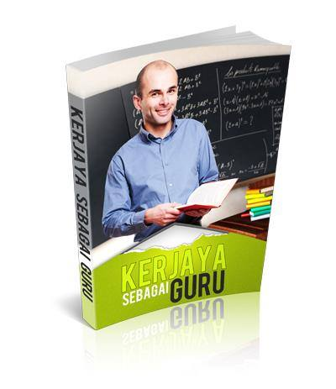



|  |  |  |  |  |
| --- | --- | --- | --- | --- |
| BIL | TINGKATAN | BIL. PELAJAR | BIL. WAKTU | MASA |
|  |  |  |  |  |
|  |  |  |  |  |
|  |  |  |  |  |
|  |  |  |  |  |
|  |  |  |  |  |
|  |  |  |  |  |
|  |  |  |  |  |





TARIKH KUAT KUASA:………………………………………….

|  |  |  |  |  |  |  |  |  |  |  |  |
| --- | --- | --- | --- | --- | --- | --- | --- | --- | --- | --- | --- |
| HARI | 1 | 2 | 3 | 4 | 5 | 6 | 7 | 8 | 9 | 10 | 11 |
| AHAD |  |  |  |  |  |  |  |  |  |  |  |
| ISNIN |  |  |  |  |  |  |  |  |  |  |  |
| SELASA |  |  |  |  |  |  |  |  |  |  |  |
| RABU |  |  |  |  |  |  |  |  |  |  |  |
| KHAMIS |  |  |  |  |  |  |  |  |  |  |  |

TARIKH KUAT KUASA:………………………………………….

|  |  |  |  |  |  |  |  |  |  |  |  |
| --- | --- | --- | --- | --- | --- | --- | --- | --- | --- | --- | --- |
| HARI | 1 | 2 | 3 | 4 | 5 | 6 | 7 | 8 | 9 | 10 | 11 |
| AHAD |  |  |  |  |  |  |  |  |  |  |  |
| ISNIN |  |  |  |  |  |  |  |  |  |  |  |
| SELASA |  |  |  |  |  |  |  |  |  |  |  |
| RABU |  |  |  |  |  |  |  |  |  |  |  |
| KHAMIS |  |  |  |  |  |  |  |  |  |  |  |

TARIKH KUAT KUASA:………………………………………….

|  |  |  |  |  |  |  |  |  |  |  |  |
| --- | --- | --- | --- | --- | --- | --- | --- | --- | --- | --- | --- |
| HARI | 1 | 2 | 3 | 4 | 5 | 6 | 7 | 8 | 9 | 10 | 11 |
| AHAD |  |  |  |  |  |  |  |  |  |  |  |
| ISNIN |  |  |  |  |  |  |  |  |  |  |  |
| SELASA |  |  |  |  |  |  |  |  |  |  |  |
| RABU |  |  |  |  |  |  |  |  |  |  |  |
| KHAMIS |  |  |  |  |  |  |  |  |  |  |  |



TARIKH KUAT KUASA:………………………………………….

|  |  |  |  |  |  |  |  |  |  |  |  |
| --- | --- | --- | --- | --- | --- | --- | --- | --- | --- | --- | --- |
| HARI | 1 | 2 | 3 | 4 | 5 | 6 | 7 | 8 | 9 | 10 | 11 |
| AHAD |  |  |  |  |  |  |  |  |  |  |  |
| ISNIN |  |  |  |  |  |  |  |  |  |  |  |
| SELASA |  |  |  |  |  |  |  |  |  |  |  |
| RABU |  |  |  |  |  |  |  |  |  |  |  |
| KHAMIS |  |  |  |  |  |  |  |  |  |  |  |

TARIKH KUAT KUASA:………………………………………….

|  |  |  |  |  |  |  |  |  |  |  |  |
| --- | --- | --- | --- | --- | --- | --- | --- | --- | --- | --- | --- |
| HARI | 1 | 2 | 3 | 4 | 5 | 6 | 7 | 8 | 9 | 10 | 11 |
| AHAD |  |  |  |  |  |  |  |  |  |  |  |
| ISNIN |  |  |  |  |  |  |  |  |  |  |  |
| SELASA |  |  |  |  |  |  |  |  |  |  |  |
| RABU |  |  |  |  |  |  |  |  |  |  |  |
| KHAMIS |  |  |  |  |  |  |  |  |  |  |  |

TARIKH KUAT KUASA:………………………………………….

|  |  |  |  |  |  |  |  |  |  |  |  |
| --- | --- | --- | --- | --- | --- | --- | --- | --- | --- | --- | --- |
| HARI | 1 | 2 | 3 | 4 | 5 | 6 | 7 | 8 | 9 | 10 | 11 |
| AHAD |  |  |  |  |  |  |  |  |  |  |  |
| ISNIN |  |  |  |  |  |  |  |  |  |  |  |
| SELASA |  |  |  |  |  |  |  |  |  |  |  |
| RABU |  |  |  |  |  |  |  |  |  |  |  |
| KHAMIS |  |  |  |  |  |  |  |  |  |  |  |



|  |  |  |  |  |  |
| --- | --- | --- | --- | --- | --- |
| **BIL** | **TARIKH** | **MASA** | **TINGKATAN/MP** | **GURU YG DIGANTI** | **AKTIVITI** |
|  |  |  |  |  |  |
|  |  |  |  |  |  |
|  |  |  |  |  |  |
|  |  |  |  |  |  |
|  |  |  |  |  |  |
|  |  |  |  |  |  |
|  |  |  |  |  |  |
|  |  |  |  |  |  |
|  |  |  |  |  |  |
|  |  |  |  |  |  |
|  |  |  |  |  |  |
|  |  |  |  |  |  |
|  |  |  |  |  |  |
|  |  |  |  |  |  |
|  |  |  |  |  |  |
|  |  |  |  |  |  |
|  |  |  |  |  |  |
|  |  |  |  |  |  |



|  |  |  |  |  |  |  |  |
| --- | --- | --- | --- | --- | --- | --- | --- |
| **BIL** | **TARIKH** | **MASA** | | **KELAS / KUMPULAN** | **KEHADIRAN MURID** | | |
| **DARI** | **HINGGA** | **L** | **P** | **J** |
|  |  |  |  |  |  |  |  |
|  |  |  |  |  |  |  |  |
|  |  |  |  |  |  |  |  |
|  |  |  |  |  |  |  |  |
|  |  |  |  |  |  |  |  |
|  |  |  |  |  |  |  |  |
|  |  |  |  |  |  |  |  |
|  |  |  |  |  |  |  |  |
|  |  |  |  |  |  |  |  |
|  |  |  |  |  |  |  |  |
|  |  |  |  |  |  |  |  |
|  |  |  |  |  |  |  |  |
|  |  |  |  |  |  |  |  |
|  |  |  |  |  |  |  |  |
|  |  |  |  |  |  |  |  |
|  |  |  |  |  |  |  |  |
|  |  |  |  |  |  |  |  |
|  |  |  |  |  |  |  |  |

|  |  |  |  |  |
| --- | --- | --- | --- | --- |
| **BIL** | **TARIKH** | **MASA** | | **AKTIVITI / PROGRAM** |
| **MULA** | **TAMAT** |
|  |  |  |  |  |
|  |  |  |  |  |
|  |  |  |  |  |
|  |  |  |  |  |
|  |  |  |  |  |
|  |  |  |  |  |
|  |  |  |  |  |
|  |  |  |  |  |
|  |  |  |  |  |
|  |  |  |  |  |
|  |  |  |  |  |
|  |  |  |  |  |
|  |  |  |  |  |
|  |  |  |  |  |
|  |  |  |  |  |
|  |  |  |  |  |
|  |  |  |  |  |
|  |  |  |  |  |
|  |  |  |  |  |
|  |  |  |  |  |

|  |  |  |  |  |
| --- | --- | --- | --- | --- |
| **BIL** | **TARIKH** | **MASA** | | **AKTIVITI / PROGRAM** |
| **MULA** | **TAMAT** |
|  |  |  |  |  |
|  |  |  |  |  |
|  |  |  |  |  |
|  |  |  |  |  |
|  |  |  |  |  |
|  |  |  |  |  |
|  |  |  |  |  |
|  |  |  |  |  |
|  |  |  |  |  |
|  |  |  |  |  |
|  |  |  |  |  |
|  |  |  |  |  |
|  |  |  |  |  |
|  |  |  |  |  |
|  |  |  |  |  |
|  |  |  |  |  |

|  |  |  |  |
| --- | --- | --- | --- |
| TARIKH/HARI |  | TEMPAT |  |
| PERSONEL TERLIBAT |  | | |
| OBJEKTIF/TAJUK PERBINCANGAN |  | | |
| INTIPATI PERBINCANGAN |  | | |
| TINDAKAN SUSULAN |  | | |
| CATATAN |  | | |

|  |  |  |  |  |  |  |  |  |  |  |  |
| --- | --- | --- | --- | --- | --- | --- | --- | --- | --- | --- | --- |
| **BIL** | **KES BERCUTI** | | | | **KES BUKAN CUTI** | | | | | | **CATATAN** |
| **1** | **2** | **3** | **4** | | **5** | **6** | **7** | **8** | **9** |
| 1 |  |  |  |  | |  |  |  |  |  |  |
| 2 |  |  |  |  | |  |  |  |  |  |  |
| 3 |  |  |  |  | |  |  |  |  |  |  |
| 4 |  |  |  |  | |  |  |  |  |  |  |
| 5 |  |  |  |  | |  |  |  |  |  |  |
| 6 |  |  |  |  | |  |  |  |  |  |  |
| 7 |  |  |  |  | |  |  |  |  |  |  |
| 8 |  |  |  |  | |  |  |  |  |  |  |
| 9 |  |  |  |  | |  |  |  |  |  |  |
| 10 |  |  |  |  | |  |  |  |  |  |  |
| 11 |  |  |  |  | |  |  |  |  |  |  |
| 12 |  |  |  |  | |  |  |  |  |  |  |
| 13 |  |  |  |  | |  |  |  |  |  |  |
| 14 |  |  |  |  | |  |  |  |  |  |  |
| 15 |  |  |  |  | |  |  |  |  |  |  |
| 16 |  |  |  |  | |  |  |  |  |  |  |
| 17 |  |  |  |  | |  |  |  |  |  |  |
| 18 |  |  |  |  | |  |  |  |  |  |  |

|  |  |  |  |  |  |  |  |  |  |  |  |
| --- | --- | --- | --- | --- | --- | --- | --- | --- | --- | --- | --- |
| **BIL** | **KES BERCUTI** | | | | **KES BUKAN CUTI** | | | | | | **CATATAN** |
| **1** | **2** | **3** | **4** | | **5** | **6** | **7** | **8** | **9** |
| 19 |  |  |  |  | |  |  |  |  |  |  |
| 20 |  |  |  |  | |  |  |  |  |  |  |
| 21 |  |  |  |  | |  |  |  |  |  |  |
| 22 |  |  |  |  | |  |  |  |  |  |  |
| 23 |  |  |  |  | |  |  |  |  |  |  |
| 24 |  |  |  |  | |  |  |  |  |  |  |
| 25 |  |  |  |  | |  |  |  |  |  |  |
| 26 |  |  |  |  | |  |  |  |  |  |  |
| 27 |  |  |  |  | |  |  |  |  |  |  |
| 28 |  |  |  |  | |  |  |  |  |  |  |
| 29 |  |  |  |  | |  |  |  |  |  |  |
| 30 |  |  |  |  | |  |  |  |  |  |  |

PANDUAN

1 = CUTI SAKIT (MC)

2 = CUTI REHAT KHAS

3 = CUTI TANPA REKOD

4 = CUTI BELAJAR

5 = MESYUARAT/BENGKEL/SEMINAR

6 = TUGAS LUAR (ARAHAN RASMI)

7 = MENGAWAS PEPERIKSAAN

8 = PENTAKSIRAN

9 = LAIN-LAIN (NYATAKAN)

**INSTRUMEN KEBERHASILAN BIDANG TUGAS 2015**

KURIKULUM

KELAS:……………………………. BIL. PELAJAR:……………………..

|  |  |  |  |  |  |
| --- | --- | --- | --- | --- | --- |
| PERKARA | TOV( KT) | ETR (S) | AR (KS) | KIRAAN | SKOR |
| UJIAN/PEPERIKSAAN |  |  |  |  |  |
| PBS |  |  |  |  |  |
| LAIN-LAIN PEMERHATIAN |  |  |  |  |  |

**CATATAN**

|  |
| --- |
|  |
|  |
|  |
|  |
|  |
|  |
|  |
|  |

**INSTRUMEN KEBERHASILAN BIDANG TUGAS 2015**

KO- KURIKULUM

PERSATUAN: ………………………………………………………… JAWATAN:…………………………………….

UNIT BERUNIFORM:………………………………………………. JAWATAN:…………………………………….

SUKAN & PERMAINAN:…………………………………………… JAWATAN:…………………………………….

|  |  |  |  |  |  |
| --- | --- | --- | --- | --- | --- |
| PERKARA | TOV( KT) | ETR (S) | AR (KS) | KIRAAN | SKOR |
| KEHADIRAN |  |  |  |  |  |
| SUMBANGAN |  |  |  |  |  |
| LAIN-LAIN |  |  |  |  |  |

**CATATAN**

|  |
| --- |
|  |
|  |
|  |
|  |
|  |

**INSTRUMEN KEBERHASILAN BIDANG TUGAS 2015**

HAL EHWAL MURID

|  |  |  |  |  |  |
| --- | --- | --- | --- | --- | --- |
| TUGAS/JAWATAN | TOV( KT) | ETR (S) | AR (KS) | KIRAAN | SKOR |
| JAWATAN KHAS: |  |  |  |  |  |
| KEHADIRAN MESYUARAT |  |  |  |  |  |
| KEHADIRAN AKTIVITI/PROGRAM SEKOLAH |  |  |  |  |  |
| PROJEK KHAS: |  |  |  |  |  |

**INSTRUMEN KEBERHASILAN BIDANG TUGAS 2015**

TUGAS-TUGAS KHAS

|  |  |  |  |  |  |
| --- | --- | --- | --- | --- | --- |
| TUGAS/JAWATAN | TOV( KT) | ETR (S) | AR (KS) | KIRAAN | SKOR |
|  |  |  |  |  |  |
|  |  |  |  |  |  |
|  |  |  |  |  |  |
|  |  |  |  |  |  |

**SUMBANGAN PROFESIONAL/BUKAN PROFESIONAL**

|  |  |  |  |
| --- | --- | --- | --- |
| BIL | JENIS SUMBANGAN | PERINGKAT | PENCAPAIAN |
|  |  |  |  |
|  |  |  |  |
|  |  |  |  |
|  |  |  |  |
|  |  |  |  |
|  |  |  |  |
|  |  |  |  |
|  |  |  |  |
|  |  |  |  |
|  |  |  |  |
|  |  |  |  |
|  |  |  |  |
|  |  |  |  |
|  |  |  |  |
|  |  |  |  |
|  |  |  |  |
|  |  |  |  |
|  |  |  |  |
|  |  |  |  |
|  |  |  |  |
|  |  |  |  |
|  |  |  |  |
|  |  |  |  |
|  |  |  |  |
|  |  |  |  |
|  |  |  |  |
|  |  |  |  |
|  |  |  |  |
|  |  |  |  |
|  |  |  |  |
|  |  |  |  |
|  |  |  |  |
|  |  |  |  |
|  |  |  |  |
|  |  |  |  |

CATATAN/NOTA

|  |  |  |
| --- | --- | --- |
| TARIKH: | MASA: | TEMPAT: |
| PERKARA: | | |
|  | | |

